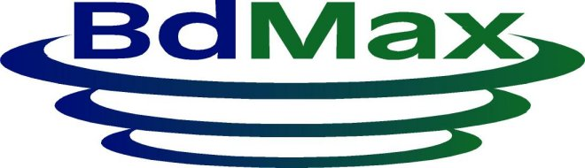
32 Tauroa Rd.,
Havelock North
027 573 5859 0800 735859
bdmax@xtra.co.nz
www.bdmax.co.nz

Material Safety Data Sheet 01 January 2025
PhotoMax

Identification

Product Name: PhotoMax

Trade Name: PhotoMax

Use: Homeopathic biodynamic Fertiliser
UN Number: None Allocated
Dangerous Goods Class: None Allocated
Hazchem Code: None Allocated
Poisons Schedule: None Allocated

Physical Description/Properties

Appearance & Odour: Clear liquid with faint herb odour

Boiling Point (C) : No Data Specific Gravity: 1.06
Vapour pressure mm/Hg: No Data Melting Point: Liquid
Vapour Density: No Data Evaporation Rate: Low
Solubility in water: completely soluble Percent Volatile: Nil

Flammability Limits Non-Flammable

Ingredients
Homeopathic dilutions Silica, Horsetail and Chamomile, mixed using a 12% alcohol base

Health Hazards

This is a relatively new product on the market. Short-term exposure by all routes is considered to be practically non-harmful.

PhotoMax is BioGro registered in New Zealand and listed as
Agricultural chemical and veterinary medicines (ACVM) exempt by the New Zealand food safety authority (NZFSA)

Swallowed: up to 250mls has no effect when swallowed by men.

Skin: Contact with the skin gives rise to no irritation.

Eyes: Unlikely to cause irritation. However there is no data available.
If irritation is caused flush the eyes with running water

Inhalation: Once again there is a shortage of data on this subject. There have been no reports of breathing difficulties from operators in the field even in windy conditions.

As with any product, ingestion, inhalation and prolonged or repeated skin contact should be avoided by good occupational work practices.

Storage &
Transport: Not defined as a Dangerous Good by the New Zealand Code for the transport of Dangerous Goods by Road and Rail.

The product is not flammable.

Spills: The product is quite soluble in water and can be flushed away with quantities of water. The material is neither slippery nor corrosive and can be simply washed into the soil.

Disposal: Should not be disposed of directly into water courses.

Fire/Explosion
Hazards: This material will not burn even if surrounded by fire due to the high concentration of water in the formulation. It is more likely to dampen a fire or present a barrier depending on how it is stacked.

